MINDTWISTER

Project Title Maximum two lines
( Verdana 24: small caps)


B.S. (SE) Final Year Project Report

Submitted by:
Name Maheen Khalid
Name Zoya Rizvi

July 20XX

Department of Computer Science and Software Engineering

Jinnah University for Women
5-C Nazimabad, Karachi 74600

Table of Contents

Project Summary 1
Algorithm 2
Project Flow 3
Code Explanation 4
Screenshots 5

Project Summary
Briefly describe your project, which problem can be solved after implementing this solution. Also mention the key functions that should be developed.

Our Project name is “Mind Twister”
It is made by using Python module Tkinter
It has 2 games
- Color game
- Number guessing game
You can play these games to refresh your mind
These are very simple and straight forward games and does not contain any complex codes

Key functions in “Color Game”:
This game consist of three functions and all are very important
Function start game is important because obviously it lets you start a game it further has two more functions inside it
Count down function and Next color function
Count down function counts the seconds till 30 then stops the game
Next color functions shows you next color if your entered answer is correct.

Key functions in “Number Guessing Game”:
This game consist of two main functions
Rando and guesser
Rando selects a random number that a user have to guess
Also it clears previous number and change background color back to normal
Guesser function helps user to guess correct number It dims and dark background color to let user know if he/she is guessing correct
Number or not.

GitHub Link
Provide GitHub link here

Algorithm
Write the algorithm of your solution with proper indentation. Your algorithm should be a complete solution of the problem stated in project summary.
Main page Algorithm:
1. Start
2. Import tkinter
3. Import message box
4. Import tkinter.Font as font
5. Set a variable window for window
6. Set window’s background color
7. Set a variable for font sizes
8. Set headings for the main page
9. Set buttons and set their onclick commands
10. Define function
11. If user clicks Guessing game destroy main page window and Import Guessing game.
12. If user clicks color game destroy main page and Import color game.
13. Set font sizes for headings and buttons
14. Set positions for headings and buttons
15. Set window’s geometry.

Guessing game Algorithm:
- Start
- Import tkinter
- Import random
- Set window
- Give title
- Set window’s geometry
- Set headings
- Define functions
Function guesser:
- If the entered data is number and
- If the guessed number is equal to computer’s selected number, It will display correct.
- If the guessed number is near to computer’s selected number, background will become darker
- If the guessed number is far from computer’s selected number, background will become Dimmer
- Or else Display error message “Hey! That's Not A Number!”

Function Rando:
- Set global variable num
- Set numbers range.
- Clear the guess box.
- Change the background color back to normal
- Set a guess box where user will enter numbers
- Make a button named submit and set function guesser on click
- Make another button named “New number” and set function rando on click
- 12.Call rando function to Generate random number on start

Color game Algorithm:
- Start
- Import tkinter
- Import random
- Make list of colors
- Initialize variable score to 0
- Initialize game timings
- Define functions
Function Start Game:
- Check if time is equal to 30 seconds call countdown function
- Call function next color to get another color
Function Next color:
- If time is greater than 0seconds make the entry box active
- If color typed is equal to the color of text plus one in variable score
- Then clear the entry box
- Shuffle colors in list
- change the color to type, by changing the text and the color to a random color value
- Update the score
Function Countdown:
- If time left is greater than 0 seconds
- Decrease the time by -1 second
- Update the time left label
- Run the function again after 1 second
- Create a GUI window
- Set the title
- Set the size
- Add an instructions label
- Add a score label
- Add a time left label
- Add a label for displaying the colors
- Add a text entry box for typing colors
- Run the start game function when the enter key is pressed
- Set focus on the entry box

Project Flow
Develop a flow chart that depicts your project flow. This should NOT be the exact mapping of algorithm.
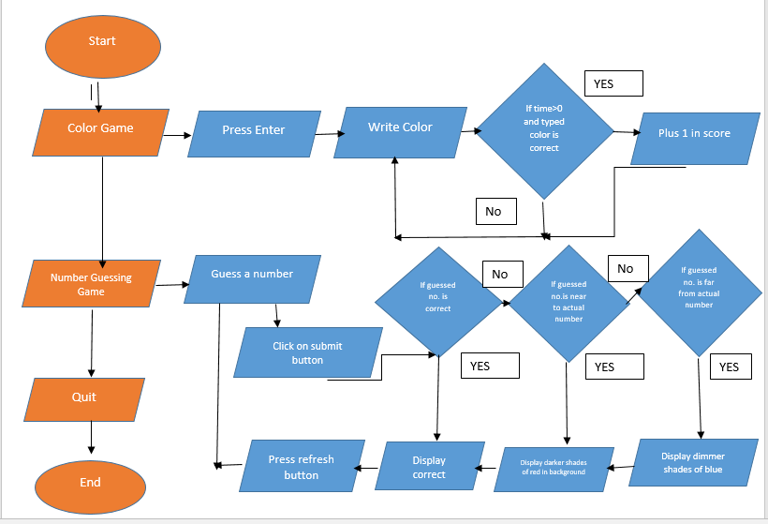

Code Explanation
Submit the code over GitHub. In this section, add code snippet in terms of functions and explain the purpose of each function.
Main Page:

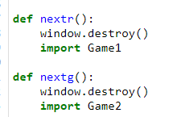
Main page has only two functions nextr and nextg
Nextr to import game 1
Nextg to import game 2

Number Guessing Game:

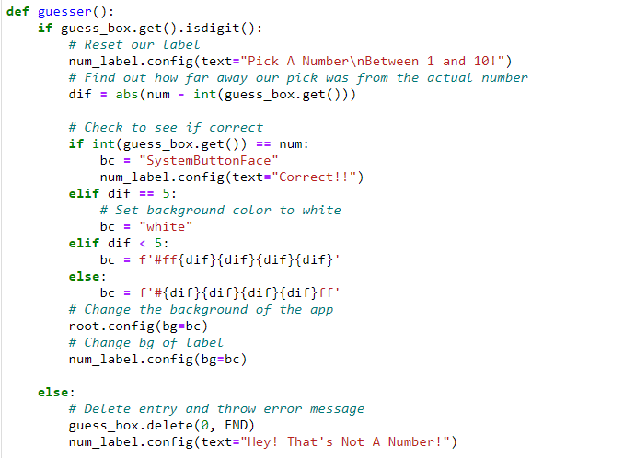
FUNCTION GUESSER:
It will first check if the entered data is number or not.. If it is number it will find out how far away guessed number was from the actual number
Check if the guessed number is correct. If correct it will display “Correct” with white background. Else if the guessed number is nearer to actual number
It will display darker shades of red and if the number is far from actual number it will display dimmer background.
If the entered data is not digit it will display an error msg

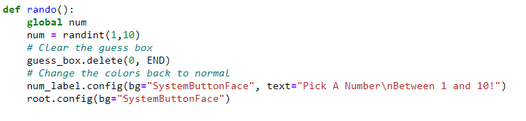
RANDO FUNCTION:
It will pick any number from 1 to 10. Also it will clear the entry box and change the background color to normal.

Color Game:
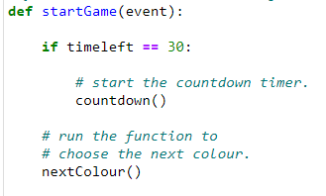
START FUNCTION: This function lets you start game if time left is equal to 30seconds It will call 2 functions
Countdown and nextcolors

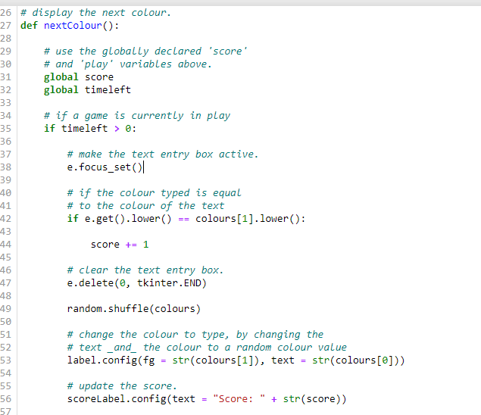
NEXT COLOR FUNCTION: If time left is greater than 0 seconds it will active text entry box. Then this function will check if the
Color typed is equal to the color of text If yes it will add 1 point in variable score then it will clear the entry box
Then again pick any random colour from list and display to user untill time left is equal to 0

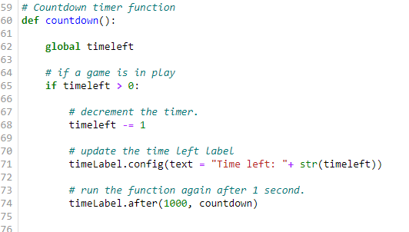
COUNTDOWN FUNCTION: If time left is greater than 0 this function will decrease it by 1 after every second

Screenshots
Add screenshots of your project with proper figure captions
Main page:

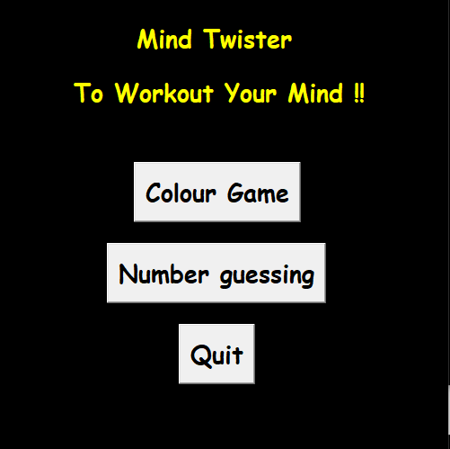

Color Game:

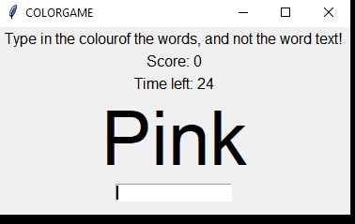

Number Gussing Game:

